What we wrote so far (27.11.18) Mixed Effects Group:

1.1 Introduction to Linear Mixed Models:

Reminder on Random Effects:

When working with data in econometrics, we have to worry about the data’s structure. Mostly there is some sort of grouping structure. It can be simple, where one grouping factor belongs to one single group or more complex. The data could have nested or hierarchical structures, or spatial elements. In the common case of longitudinal data we have repeated measures over time of one cross-sectional element.
In all of the cases above we would assume some relation within a specific group (cross-sectional element). However, one of the standard assumptions of traditional ‘pooled’ linear regression models is that residuals are independently and identically distributed (i.i.d.). This means that after considering for all covariates, there are no correlations left between measures. By implementing this on longitudinal data of a population sample, we would assume that any two individuals of this population are identical, for example. In many cases this assumption is unreasonable. Especially with hierarchical data and temporal hierarchies that are often characterized by dependence over time (Buch xy) errors are unlikely to be i.i.d..
Random effects can model these grouping structures. Instead of trying to estimate the value of the random effects we will estimate the variance of their distribution. This distribution is different for each group we are accounting for. Thus accounting for heterogeneity across groups and improving the model by making the assumptions more realistic.

Mixed Models:

In mixed effects models we consider both, random and fixed effects at the same time. Generally, the
Nᵢ serial measurements (synonym?) yᵢ of subject I are modelled as
yᵢ = Xᵢ beta + Zᵢbᵢ + epsilonᵢ
with Xᵢ being subject i’s nᵢ*p design matrix containing fixed effects observations, beta the fixed effects regression coefficient vector of length p to be estimated, Zᵢ’columns contain the subset of Xᵢ’s we want to account for by random effects bᵢ, with epsilon being the residuals not explained by either fixed or random effects. More precisely, any component of beta can be allowed to vary randomly on the subject specific level by simply including the corresponding columns of X in Z (Bernal-Rusiel et al. , 2013)CHECK THIS. This will be further explored in the subsequent sections.
Here, the following assumptions made on the model are
ASSUMPTIONS
M is the number of subjects and bi represents the deviations of subject I from the populations coefficients for the subset Zᵢ, with D being the covariance matrix of bi’s distribution. This allows subjects to deviate from the populations values, accounting for inter-subject variability (Zhang 2015).
The beauty of including random effects in our standard model is that it also permits us to model intra-subject measurement correlations. To show this, we will first distinguish the marginal (population-average) mean E{yi} from the conditional (subject-specific) mean E{yi|bi}:
FORMULAS
Now we can compute the subject-specific covariance Cov{yi|bi} and the population-average covariance Cov{yi}:
FORMULAS
While sigma2 is a diagonal matrix, ZDZt is not. Hence, the addition of both, Cov{yi}, is a matrix with off-diagonal elements, which enables us to model intra-subject measurement correlations.
Putting everything together, we get the common notation:
yi distr. N(Xibeta,Hi(sigma))
with Hi=ZDZ + sigma 2I

Generally, the mixed effects model is useful when the data structure suggests there are good arguments for fixed and random effects, as opposed to the case where either one is preferred. This way we could account for population and individual effects. In the following section we will introduce two types of mixed effect models, to later explain the relevant estimation techniques.

1.2 Random Intercept Model
Since panel data relate to individuals, firms, states, countries, etc.over time, there is bound to be heterogeneity in these clusters. How to take such heterogeneity explicitly into account? First let us imagine the simplest type of cluster-specific heterogeneity(Fig7.1, right part)
The estimates are based on artificial data drawn from the model yij = 1 + xij +ε ij, i=1,…,10, j = 1,…,20, for m = 10 individuals or clusters, ni = 20 repeated measurements in each cluster, and i.i.d. errors ε ij ∽N(0,0.1^2). The dashed line corresponds to the population model. The estimated cluster-specific regression lines show a common slope across clusters, but the intercept appears to be different from cluster to cluster.
2, random intercept model, explain all the parameters
To model this type of cluster-specific heterogeneity, we introduce this type of cluster-specific parameters γ0iand obtain equation(7.2)
Yij = β0 + β1xij+γ0i+εij,
(explain why 0 and i)
Where εij ~ N(0,δ^2) are the usual i.i.d. errors of the classical linear model. In Eq. (7.2):
• β0 is the “fixed” population intercept.
• γ0i is the cluster-specific (random) deviation from the population intercept β0. Since the clusters are a random sample from a larger population，the cluster-specific parameters γ0i are assumed to be random with
γ0i ~i.i.d N（0，τ^2）（7.3）
• β0 +γ0i is the (random) intercept for cluster i. The random intercepts β0+γ0i ~ N(β0,τ0^2) ay be interpreted as effects of omitted (cluster-specific) covariates and account for unobserved heterogeneity.
• β1 is a “fixed” population slope parameter of covariate x that is common across clusters.
• assume mutual independence between the εij and the γ0i. The random intercept model appears as a linear regression model with two error terms, where γ0i is then a cluster-level error shared between measurements on the same individual or cluster i and εij is the observation error of measurement j in cluster i.
3, marginal model(the difference in estimation of β between ols and random, maybe it is better to put it in the estimation part?)
4,limitations, of this model ,(within- and between-cluster effects, and be not randomly sampled)
he random intercept model (7.2) considered thus far has an important limitation: The so-called within- and between-cluster effects of x are the same. The withincluster effect denotes the effect if x changes within the same individual at different occasions. The between-cluster effect refers to different x values between different subjects or clusters. In either case, a difference of one unit of x in model (7.2) induces a difference of ˇ1 in expected responses. This equality between the within- and between-cluster effect might be questionable in

1.4 Random Slope Model
1.4.1 Why would random slope model be considered?
From the random intercept model discussed above, we know that cluster-specific parameters should be included due to cluster-specific heterogeneity. Given the restrictive assumption that the covariate effect of x is equal in size for each individual or cluster in random intercept model, there could be another case that the intercept for the regression lines seems to be identical (or at least close), whereas the slopes are clearly different (figure 4.1). More typical is the situation where the regression lines exhibit both cluster-specific intercepts and slopes (figure 4.2).

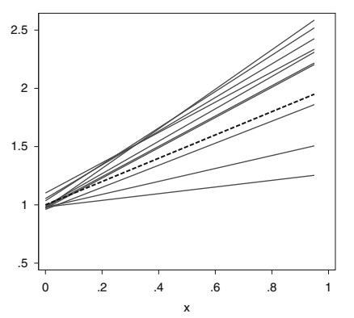
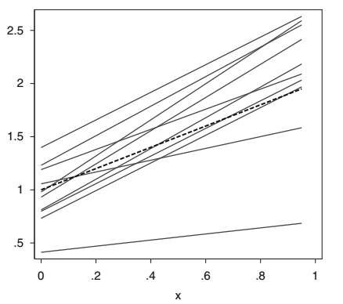
Figure 4.1 figure 4.2
Figure 4.1 shows it’s a model with most random intercept parameters γ0i zero or close to zero and random slope parameters γ1i different from zero, the variability of cluster-specific intercepts is close to zero and the variability of cluster-specific slopes is larger than zero.
Figure 4.2 shows it’s a model with both random coefficients away from zero, the variability of cluster-specific intercepts and slopes are both larger than zero.

1.4.2 Random slope model construction
yij=β0+β1 xij+γ0i+γ1i xij+eij (*)
where:• β1 is the “fixed” population slope of the effect of x.
• γ1i is the individual- or cluster-specific deviation for the slope.
• β1 xij is the population effect of x.
• β1 xij+γ1i xij is the cluster-specific effect of x.
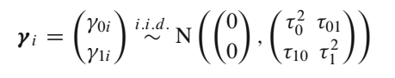
1.4.3 Correlation structure on observations
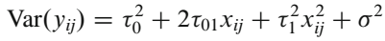
We can see the marginal variances depend quadratically on the covariate values.
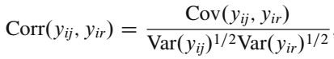
We can see an intraclass correlation coefficient exists between observations yij and yir in the same cluster. It depends in a rather complicated way on the observed covariate values and is very difficult to interpret

Remark: (*) taken from (7.1.2 of Methods and applications 2013 Fahrmeir)
Estimation Techniques
A general linear mixed model is given by
y=Xβ+Uγ+ε
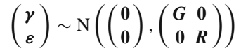
Assumption：G and R are nonsingular, and therefore positive definite. γ and εare independent.
Case Ⅰ：Known variance-covariance parameters
We assume all parameters in G and R are known, unknown parameters can be estimated by simultaneously maximizing the joint log-likelihood of y, γwith respect to βand γ， V= R+ UGU’ , we get
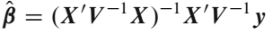
(calculation part ignored temporarily)
Conclusion: (βhat) is a weighted least squares estimator with the inverse of the marginal covariance matrix V= R+ UGU’ as the weight matrix.

Case Ⅱ: Unknown variance-covariance parameters
1, Maximum Likelihood
.......
2, Restricted maximum Likelihood(often based on marginal or restricted log-likelihood)
.......
3, Comparison these two ways
.......

